

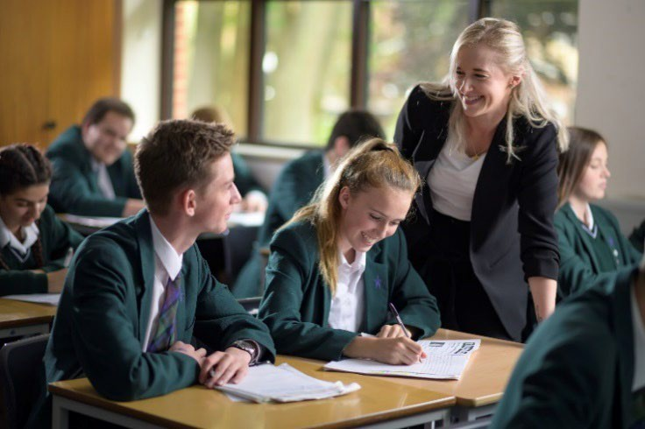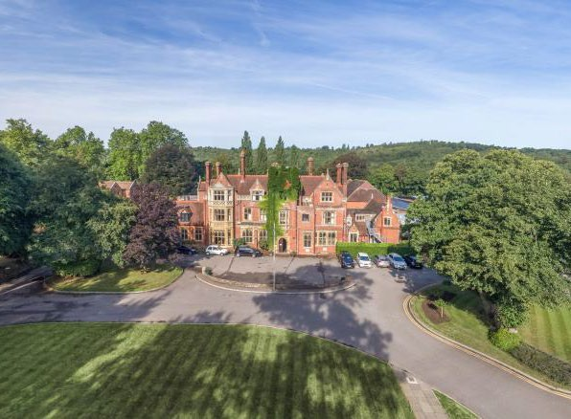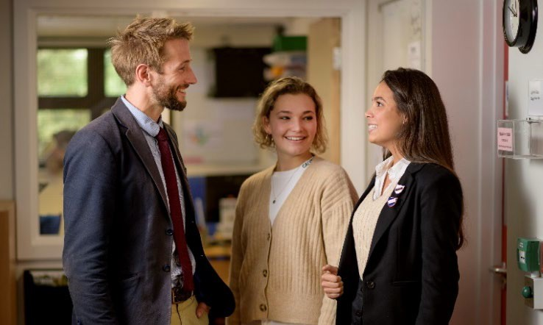

**Lead Nurse**



**Introduction**

Box Hill School is a non-selective, co-educational boarding and day school for 425 girls and boys aged 11-

18. Set in 40 acres in the rolling Surrey countryside, the school is situated at the heart of Mickleham village, but close to major road, rail and air links and only 40 minutes from central London.

The ethos of the school is anchored firmly in the belief that all pupils should reach their maximum potential. They are encouraged, nurtured and challenged in all they do. We believe that a strong academic tradition, combined with outstanding pastoral guidance produces well-adjusted young people, ready to greet the world with energy, confidence and enthusiasm. The school has a long heritage of delivering first- class learning in a warm, supportive, holistic and nurturing atmosphere. We aim to promote international understanding, democracy, a care for the world around us, a sense of adventure and the qualities of leadership and service to others.

The School is led by the Headmaster, Mr Cory Lowde and governed by a board that brings a wealth of experience to support the school’s successful and forward thinking management. Box Hill School is committed to maintaining its distinctive ethos: preparing young people for life by facing it directly within a supportive but challenging environment. It is a school that dares to be different from the normal public school mould.

# A Brief History

The school was founded in 1959 and since then, it has had only four Headmasters, including our current Head. This commitment to our school by its leaders shows how special and tight-knit our community is. The main building, Dalewood House, was built in 1883 and has a magnificent mix of mock Tudor and Gothic styling. Fine wood panelling, hand painted tiles, fireplaces and beautifully crafted and themed stained glass windows are features throughout. Externally, the grounds and facilities reflect the growth and development of the school through the years. Our most recent new building, a state of the art Sixth Form Centre and teaching and learning space demonstrates our ambition to provide our pupils with a vibrant, progressive and creative environment in which to be educated. In spring 2018 a new Sports complex will be completed which will significantly enhance our facilities and provide opportunities to extend our sports provision.

# Round Square

The school is a founder member of Round Square, a worldwide association of schools sharing the philosophy of Dr Kurt Hahn – to place academic work at the heart of the school whilst emphasising the importance of an all-round, holistic education as preparation for life.

He inspired a set of principles or IDEALS (**I**nternationalism, **D**emocracy, **E**nvironmental stewardship,

**A**dventure, **L**eadership and **S**ervice) that are embedded into the Box Hill School way of life.

Central to this is the spirit of ‘having a go’ whether academic work, performing on stage, scaling a climbing

wall or taking part in expeditions at home or abroad, all are aimed at unlocking potential in pupils. Membership of Round Square gives pupils unparalleled opportunities for travel and adventure, and we have a number of on-going overseas aid projects in which they can participate and in exchanges to other Round Square schools around the world.

**The Role**

# Job Purpose

* **The purpose of the Medical Centre**
* To provide a high-quality nursing service to the school community by working both proactively and reactively, and embracing new technologies as required. Delivering that quality of service requires an enthusiastic, harmonious, and mutually supportive team.
* **Role of the Lead Nurse**
* To lead and manage a clinically effective, enthusiastic and mutually supportive team to deliver a high-quality nursing care service for all members of the school community. This involves coordinating the daily running of the school Medical Centre and associated services, effective communication within school and parent body and working within agreed school and professional protocols.
* **Responsible to**
* The Operations Manager
* **Main Duties and Responsibilities**
* To coordinate the daily running of the school medical centre, including line managing the staff within the nursing team.
* To establish the use of best practice to maintain a high quality of nursing care to the school community and ensure that this is constantly reviewed to improve the service provided.
* To work closely with and establish good communication with parents, guardians, DSL, deputy heads, boarding staff and other teaching staff to ensure that the highest possible standards of care are given.
* To develop, maintain and update appropriate policies and protocols, supported by evidence-based practice, ensuring this is communicated to all members of the nursing team and wider school community where relevant.
* To have a good working knowledge of the Independent Schools Inspectorate (ISI) inspection procedure and ensure that all the nursing team have a good understanding of those National Minimum Standards (NMS) particularly relevant and that they are adhered to.
* To participate in the recruitment and selection of medical centre staff and coordinate their orientation in collaboration with the HR Department and Operations Manager.

* To ensure all staff within the medical centre receive annual appraisals.
* To support and ensure all registered nurses in the team maintain their nursing accreditation and continuous professional development record and revalidate in a timely manner.
* To prepare and manage annual departmental budget.
* To ensure the medical centre has a robust medication procedure and that the nursing team are aware of recommendations and maintain safe storage, usage and disposal of medical supplies and drugs.
* To ensure the provision of confidential guidance and health advice as appropriate for those requiring psychological support.
* To lead procedures for the control of infectious diseases and advise on outbreaks of communicable diseases, including hands-on care for those students in isolation are followed.
* Review the health status of boarders on entry to the school and ensure appropriate action and communication is taken.
* To keep up to date with current health promotion initiatives and to undertake and deliver training as appropriate.
* To organise staff training on asthma and anaphylaxis, and other health issues as appropriate to the staffing of specific students (e.g., diabetes, epilepsy, and the management of other chronic conditions)
* To organise training for all staff working within boarding to ensure they have the knowledge, skills, and competency to undertake all aspects of safe medicine management.
* Ensure all members of team follow safe working practice and always comply with the school’s Health and Safety Policies and Procedures.

**Person Specification**

**PERSON SPECIFICATION**

|  |  |  |  |  |
| --- | --- | --- | --- | --- |
| **Attributes** | **Essential Criteria** | **Essential** | **Desirable** | **How Assessed** |
| Qualifications | * RSCN, RN-Child or * RGN with relevant experience | ✓  ✓  ✓ |  | Application Form |
| Professional Experience | * Previous experience working with children and adolescents. * Minimum 3 years post-registration experience. * Experience of working in an educational setting * Experience in A&E/ Triage setting * Experience in supporting the mental health of individuals. * Previous management experience * Good working knowledge of child protection issues (training will be provided on appointment if needed) | ✓  ✓ | ✓  ✓  ✓  ✓  ✓  ✓ | Application Form Interview References |
| Knowledge and understanding | * The ability to demonstrate an understanding of school protocols and policies and a full acceptance for the need of compliance. * Knowledge of safeguarding Children in Education * Willingness to keep up to date with clinical knowledge, attending training as required * Knowledge and understanding of sports injuries | ✓  ✓  ✓ | ✓ | Application Form Interview |

|  |  |  |  |  |
| --- | --- | --- | --- | --- |
|  |  |  |  |  |
| Skills | * Excellent problem-solving skills and ability to use initiative in challenging situations. * Ability to work independently without medical back up on site. * Excellent communication and interpersonal skills with children, parents /guardians, and all members of staff across the whole school * Confident and calm under pressure and work to tight deadlines, managing competing priorities. * Computer literate, particularly Outlook, Excel and Word * Ability to teach first aid/ anaphylaxis. * Ability to assist in PHSEE programs. * Experience of ISAMS data base and Medical Centre module | ✓  ✓  ✓  ✓  ✓ | ✓  ✓  ✓  ✓ | Application Form Interview |
| Personal Qualities | * An exemplary record in their current and previous employment. * Diplomatic and confidential. * Friendly, sympathetic, and supportive personality * Willingness to make a full contribution to life in the school. | ✓  ✓  ✓  ✓ |  | Interview References |

|  |  |  |  |  |  |  |
| --- | --- | --- | --- | --- | --- | --- |
|  |  |  |  |  |  |  |
|  | Continuing Professional Development | * Evidence of personal commitment to professional development | ✓ |  | Interview |  |
| **Terms and Conditions** | | | | | | |

* Lunch is provided free of charge during term time
* Cycle to work scheme
* Pension Scheme provided through Legal and General
* Staff on-site parking
* Use of the school gym
* Staff discount on school fees
* The successful applicant will be required to complete a pre-employment medical questionnaire.
* Salary competitive within the sector and commensurate with the successful candidate’s experience

**Child Protection and Safeguarding**

The Governors of Box Hill School are committed to safeguarding and promoting the welfare of children and young people and expect all staff to share this commitment. Applicants must be willing to undergo child protection screening appropriate to the post. This will include making an enhanced disclosure to the Disclosure and Barring Service. Further details about the school’s policy regarding Safeguarding and Disclosure in relation to recruitment and selection can be found on the Current Vacancies page of our website [www.boxhillschool.com](http://www.boxhillschool.com/)

**Applications**

Applicants are requested to provide a **letter of application addressed to the Operations Manager** plus the schools **Application Form** and **Equal Opportunities Monitoring Form** in full (CVs will not be accepted in place of the completed Application Form but may be included as part of the application process).

Please also note that the **Explanatory Note** regarding our application and recruitment process should also be read and can be found on the website on the Current Vacancies page.

Applications should be sent with a covering letter explaining suitability for the role (by post or email) to: [hradmin@boxhillschool.com](mailto:hradmin@boxhillschool.com)

**Early applications are encouraged as we reserve the right to appoint before the closing date.**

The closing date for applications is **Friday 10th March 2023.**